Asymmetric DCC correlation: USDCHF and EURGBP
Method 10 / GARCH(1,1) + Cappiello-Engle-Sheppard ADCC / Alpari D1 full available history

Study setup
Logical pair: USDCHF , EURGBP
Broker symbols: USDCHF_i , EURGBP_i
Snapshot: 2026-11-03_majors_alpari_D1
Timeframe: D1
Matched return window: 1999-01-06 to 2026-11-02 (UTC bar dates)
Matched return count n: 7182
Dropped unfinished last bar dated 2026-11-03 UTC after a tick-volume check against the prior complete day.
USDCHF GARCH(1,1): mu=-0.000341, omega=0.003441, alpha=0.041011, beta=0.956758
EURGBP GARCH(1,1): mu=-0.000019, omega=0.000658, alpha=0.046457, beta=0.951873
ADCC: a=0.046236, b=0.926142, g=0.000000, a+b+g/2=0.972377
Nested DCC (g=0): a=0.046236, b=0.926142
Negative shock: n = min(z, 0) in broker quote direction (not inverted)
Burn-in ignored in path summaries and chart: first 60 updates
Complete matched rows (Excel): USDCHF-EURGBP_ADCC_D1.xlsx
Complete matched rows (HTML table): USDCHF-EURGBP_ADCC_D1_data.html

Method carried forward
Asymmetric DCC extends Engle DCC with an extra term on joint negative standardised shocks. Each matched daily log return of close, ln(close_t / close_t-1), is first filtered by a constant-mean GARCH(1,1). Then z = residual / sigma and n = min(z, 0). The Cappiello-Engle-Sheppard recursion uses A = (1-a-b) Q_bar - g N_bar with N_bar = mean(n n'). Quotes are not inverted, so a negative shock is a negative log return in the broker quote. Nested symmetric DCC (g = 0) is fit on the same z path for comparison. Constraints: a,b,g >= 0 and a + b + g/2 < 1. Path summaries ignore the first 60 updates. The headline is latest ADCC rho. Pearson r is a side check only. This is not a cause, lead, or trading signal.

Results
Latest ADCC rho: -0.061088
Latest nested DCC rho: -0.061088
Post-burn-in ADCC path (n=7122): mean=-0.308574, median=-0.321783, min=-0.724757, max=0.469067, std=0.172066
Share of post-burn-in days with |rho| >= 0.4: 33.02%; |rho| >= 0.7: 0.06%
Same-sample Pearson r: -0.325886
ADCC minus r: 0.264798
ADCC minus nested DCC: -0.000000

Conclusion
Over 7182 matched daily log-return rows for USDCHF and EURGBP (broker quote directions unchanged), latest ADCC rho is -0.0611 (negative, weak conditional linear link in this sample) with fitted a=0.0462, b=0.9261, g=0.0000. Nested symmetric DCC latest rho is -0.0611 (ADCC minus DCC = -0.0000). After a 60-day burn-in, path mean is -0.3086 and std is 0.1721. Same-sample Pearson r is -0.3259 (ADCC minus r = 0.2648). This does not establish cause, lead-lag, or a lasting trading rule.

Charts
Daily closes

Daily log returns
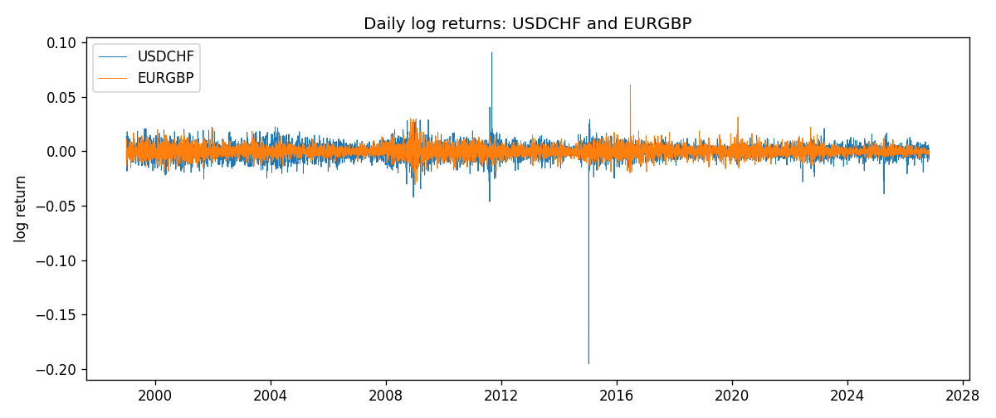
ADCC rho path with nested DCC and Pearson r
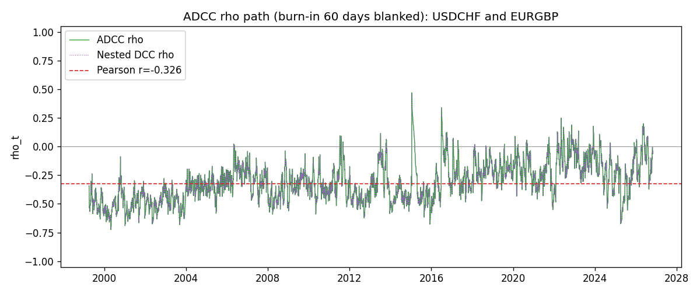

Data report
Every matched row that entered the ADCC recursion is stored in the sibling Excel workbook named USDCHF-EURGBP_ADCC_D1.xlsx. Embedding all rows as a Word table is impractical at this length; the Word file holds the column list, column summaries, and the first and last 15 matched rows.
Columns: time, USDCHF_open, EURGBP_open, USDCHF_high, EURGBP_high, USDCHF_low, EURGBP_low, USDCHF_close, EURGBP_close, USDCHF_tick_volume, EURGBP_tick_volume, USDCHF_spread, EURGBP_spread, USDCHF_real_volume, EURGBP_real_volume, USDCHF_log_return, EURGBP_log_return, USDCHF_sigma, EURGBP_sigma, USDCHF_z, EURGBP_z, USDCHF_n, EURGBP_n, q11, q22, q12, rho_adcc, rho_dcc
Column summaries (matched calculation rows)
column | count | mean | std | min | 25% | 50% | 75% | max
USDCHF_open | 7182 | 1.0972493 | 0.25210985 | 0.72022 | 0.9204925 | 0.989875 | 1.237175 | 1.8219
EURGBP_open | 7182 | 0.7869939 | 0.09664695 | 0.5734 | 0.6877 | 0.833905 | 0.865225 | 0.9769
USDCHF_high | 7182 | 1.1025378 | 0.25385182 | 0.73305 | 0.924695 | 0.99351 | 1.242175 | 1.8313
EURGBP_high | 7182 | 0.79007306 | 0.09702085 | 0.5789 | 0.6897 | 0.836955 | 0.8681 | 0.9799
USDCHF_low | 7182 | 1.092133 | 0.25052689 | 0.08565 | 0.9171825 | 0.986205 | 1.2312 | 1.8121
EURGBP_low | 7182 | 0.7842938 | 0.09646529 | 0.5682 | 0.685725 | 0.83166 | 0.86287 | 0.9661
USDCHF_close | 7182 | 1.09724 | 0.25200902 | 0.72025 | 0.9207375 | 0.98991 | 1.23715 | 1.8217
EURGBP_close | 7182 | 0.78703952 | 0.09664503 | 0.5735 | 0.687825 | 0.83398 | 0.865375 | 0.977
USDCHF_tick_volume | 7182 | 74362.695 | 113509.88 | 18 | 12814.25 | 40258.5 | 70446 | 858589
EURGBP_tick_volume | 7182 | 87145.49 | 145506.26 | 154 | 6593.75 | 44371 | 81432 | 1424684
USDCHF_spread | 7182 | 26.020746 | 24.692144 | 0 | 5 | 16 | 50 | 100
EURGBP_spread | 7182 | 21.320663 | 19.117614 | 0 | 4 | 13 | 40 | 50
USDCHF_real_volume | 7182 | 2.3303821e+10 | 8.915094e+10 | 0 | 0 | 0 | 0 | 1.9331921e+12
EURGBP_real_volume | 7182 | 2.7876168e+10 | 1.3522356e+11 | 0 | 0 | 0 | 0 | 3.5726265e+12
USDCHF_log_return | 7182 | -7.199e-05 | 0.00659004 | -0.19545699 | -0.00335239 | 7.626e-05 | 0.00331734 | 0.09051364
EURGBP_log_return | 7182 | 2.529e-05 | 0.00487429 | -0.03067367 | -0.00262165 | -0.00010006 | 0.00256425 | 0.06075387
USDCHF_sigma | 7182 | 0.00654709 | 0.00255019 | 0.00361398 | 0.00507601 | 0.00609961 | 0.00729341 | 0.03990355
EURGBP_sigma | 7182 | 0.00463787 | 0.00169441 | 0.00185854 | 0.00343944 | 0.00442348 | 0.00552855 | 0.01547073
USDCHF_z | 7182 | 0.0393536 | 0.99904315 | -34.479539 | -0.48261344 | 0.06929381 | 0.59706596 | 6.7440511
EURGBP_z | 7182 | 0.00820558 | 1.0000734 | -3.7919663 | -0.62081539 | -0.02007425 | 0.59868396 | 8.4814176
USDCHF_n | 7182 | -0.33065924 | 0.6792352 | -34.479539 | -0.48261344 | 0 | 0 | 0
EURGBP_n | 7182 | -0.37922622 | 0.57004047 | -3.7919663 | -0.62081539 | -0.02007425 | 0 | 0
q11 | 7182 | 1.0000397 | 1.7132627 | 0.54944603 | 0.77045665 | 0.867156 | 0.98638404 | 55.732844
q22 | 7182 | 1.0004442 | 0.23615325 | 0.60989725 | 0.84671711 | 0.95865203 | 1.1045109 | 4.5049681
q12 | 7182 | -0.29130325 | 0.2295173 | -1.6292736 | -0.40611697 | -0.2921365 | -0.17419065 | 3.7390537
rho_adcc | 7182 | -0.30929806 | 0.17163286 | -0.72475657 | -0.436958 | -0.32286609 | -0.19968281 | 0.46906703
rho_dcc | 7182 | -0.30929805 | 0.17163287 | -0.7247566 | -0.43695801 | -0.32286609 | -0.19968277 | 0.46906683
First 15 matched rows (selected columns)
time | USDCHF_log_return | EURGBP_log_return | USDCHF_z | EURGBP_z | USDCHF_n | EURGBP_n | q11 | q22 | q12 | rho_adcc | rho_dcc
1999-01-06 | 0.013605652 | -0.013303338 | 1.6297902 | -2.3722391 | 0 | -2.3722391 | 1 | 1 | -0.29129805 | -0.29129805 | -0.29129805
1999-01-07 | -0.0093883841 | 0.011051402 | -1.0219401 | 1.7932277 | -1.0219401 | 0 | 1.0765762 | 1.2139564 | -0.45658842 | -0.39939345 | -0.3993934
1999-01-08 | 0.011040268 | -0.004943862 | 1.2829737 | -0.75954358 | 0 | -0.75954358 | 1.0729715 | 1.3005967 | -0.51564215 | -0.43649872 | -0.43649866
1999-01-11 | 0.0052963193 | -0.0012752393 | 0.62656043 | -0.19566338 | 0 | -0.19566338 | 1.0974512 | 1.2588332 | -0.5306596 | -0.45148084 | -0.45148077
1999-01-12 | -0.0098275602 | 0.0033970309 | -1.0667098 | 0.54450489 | -1.0667098 | 0 | 1.0621691 | 1.1952507 | -0.50518068 | -0.44835334 | -0.44835328
1999-01-13 | -0.018259701 | 0.00042381861 | -2.0070546 | 0.071796529 | -2.0070546 | 0 | 1.0639519 | 1.1483023 | -0.50277033 | -0.45486291 | -0.45486285
1999-01-14 | -0.0024256692 | -0.0019793588 | -0.22003654 | -0.32525048 | -0.22003654 | -0.32525048 | 1.1992425 | 1.0913516 | -0.48034554 | -0.41987295 | -0.41987292
1999-01-15 | 0.01794228 | -0.0076715819 | 1.9667938 | -1.2969011 | 0 | -1.2969011 | 1.1405297 | 1.0432601 | -0.44960552 | -0.41217537 | -0.41217535
1999-01-18 | -0.0031856384 | 0.00071280921 | -0.2892473 | 0.12212831 | -0.2892473 | 0 | 1.2627672 | 1.0715955 | -0.54237987 | -0.4662582 | -0.46625815
1999-01-19 | -7.2518946e-05 | -0.0014261269 | 0.027791061 | -0.2402669 | 0 | -0.2402669 | 1.2009922 | 1.0207615 | -0.51200034 | -0.46242148 | -0.46242144
1999-01-20 | 0.0072259871 | 0.0019960086 | 0.79966401 | 0.35189487 | 0 | 0 | 1.1399473 | 0.97566156 | -0.48254003 | -0.45755294 | -0.4575529
1999-01-21 | -0.0038232689 | -0.00071240297 | -0.37047102 | -0.12356316 | -0.37047102 | -0.12356316 | 1.1129414 | 0.93694885 | -0.44193627 | -0.43277838 | -0.43277836
1999-01-22 | -0.0001445609 | -0.0017118406 | 0.021242848 | -0.30879547 | 0 | -0.30879547 | 1.0647099 | 0.89607595 | -0.41522553 | -0.42510479 | -0.42510477
1999-01-25 | 0.0024546976 | -0.0054402425 | 0.30865252 | -1.0101752 | 0 | -1.0101752 | 1.0137157 | 0.86192472 | -0.3929074 | -0.42033684 | -0.42033682
1999-01-26 | 0.0020889617 | -0.00057438255 | 0.27311368 | -0.10337131 | 0 | -0.10337131 | 0.97087172 | 0.87306842 | -0.38635032 | -0.41963935 | -0.41963934
Last 15 matched rows (selected columns)
time | USDCHF_log_return | EURGBP_log_return | USDCHF_z | EURGBP_z | USDCHF_n | EURGBP_n | q11 | q22 | q12 | rho_adcc | rho_dcc
2026-10-13 | -0.0024955621 | 0.00020130374 | -0.4512156 | 0.10934532 | -0.4512156 | 0 | 0.71275226 | 0.81866396 | -0.17288967 | -0.22633249 | -0.22633243
2026-10-14 | 0.0029388325 | 0.0011241873 | 0.6936966 | 0.57607618 | 0 | 0 | 0.69714558 | 0.78637427 | -0.17044793 | -0.23020532 | -0.23020526
2026-10-15 | -0.0097855323 | -0.00087557391 | -2.0058323 | -0.4349504 | -2.0058323 | -0.4349504 | 0.6955275 | 0.77126056 | -0.14742856 | -0.20129079 | -0.20129075
2026-10-16 | -0.0036230826 | -0.0020380844 | -0.65364681 | -1.0370538 | -0.65364681 | -1.0370538 | 0.85780253 | 0.75066614 | -0.10424841 | -0.12991293 | -0.12991295
2026-10-19 | 0.0036351779 | -0.00056950988 | 0.79663716 | -0.27999979 | 0 | -0.27999979 | 0.8418237 | 0.7725714 | -0.07325358 | -0.09083411 | -0.09083415
2026-10-20 | -0.0026281224 | -0.0035906254 | -0.45906038 | -1.8426518 | -0.45906038 | -1.8426518 | 0.83661323 | 0.74675808 | -0.086202847 | -0.10906095 | -0.10906097
2026-10-21 | -0.00040027413 | -0.00140647 | -0.012052604 | -0.67417325 | -0.012052604 | -0.67417325 | 0.81218856 | 0.87621342 | -0.04877224 | -0.057814839 | -0.057814891
2026-10-22 | -0.0048036381 | -0.0018743924 | -0.91858207 | -0.90678488 | -0.91858207 | -0.90678488 | 0.77983103 | 0.86013497 | -0.052840721 | -0.064518636 | -0.064518676
2026-10-23 | 0.005652514 | 0.00082421033 | 1.2299741 | 0.41106314 | 0 | 0 | 0.78886999 | 0.86224717 | -0.018472106 | -0.022397411 | -0.022397475
2026-10-26 | 0.0018407959 | 0.00013133309 | 0.44045118 | 0.07429369 | 0 | 0 | 0.82817501 | 0.83399826 | -0.0017775786 | -0.0021388739 | -0.0021389375
2026-10-27 | 0.0026100526 | -0.0019957343 | 0.60219239 | -0.9913047 | 0 | -0.9913047 | 0.80359962 | 0.80027839 | -0.0081797346 | -0.010199968 | -0.010200017
2026-10-28 | -0.0010142111 | 0.00066967224 | -0.13838874 | 0.34309623 | -0.13838874 | 0 | 0.78863644 | 0.81422891 | -0.043222658 | -0.053938616 | -0.053938629
2026-10-29 | -0.0048680164 | -0.0011722209 | -0.9436868 | -0.58196144 | -0.9436868 | -0.58196144 | 0.75889719 | 0.7871566 | -0.050272011 | -0.065043547 | -0.065043547
2026-10-30 | 0.00071594559 | -0.0024205543 | 0.21938728 | -1.2216166 | 0 | -1.2216166 | 0.77164389 | 0.77230023 | -0.029213274 | -0.037842402 | -0.03784242
2026-11-02 | -0.0071459744 | 0.00089940465 | -1.4317796 | 0.4586351 | -1.4317796 | 0 | 0.74449956 | 0.81188174 | -0.047493524 | -0.061087983 | -0.061087978

